Odessa Regional Institute
for Public Administration
of the National Academy
for Public Administration
under the President of Ukraine
Management of Organizations Chair
Students’ Self-Government

XXII Annual International and Ukrainian, theoretical and practical conference for students:

“Modern Management:
Models, Strategies, Technologies”

22 April, 2021

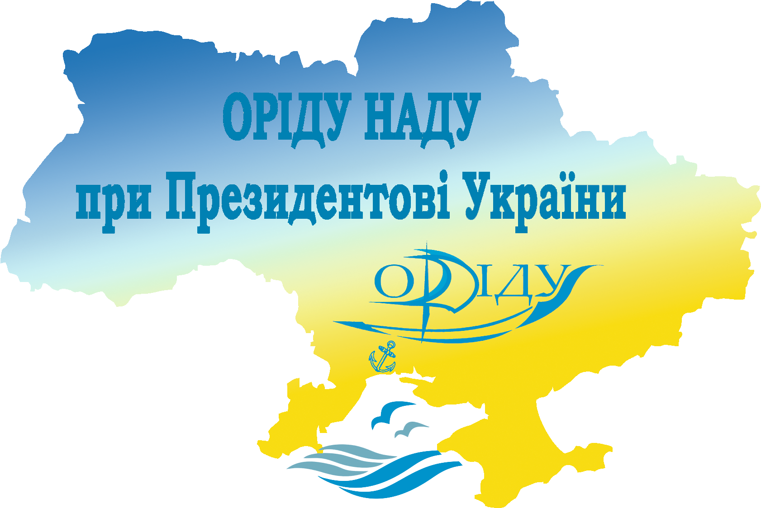

Odesa

DEAR COLLEAGUES!

Postgraduate, master and bachelor students are invited to take part in the XXII Annual International and Ukrainian, theoretical and practical conference for students: “Modern Management: Models, Strategies, Technologies”, which will be held on April 22, 2021 in the Odessa Regional Institute for Public Administration of the National Academy for Public Administration under the President of Ukraine: Odesa, 22 Genuezka str., room 401

THE ORGANIZING COMMITTEE
N. Krasnostanova — chairperson, head of Management of Organizations Chair.
V. Vishnevska — co-chairperson, acting dean of Management and Business Technologies Faculty.
S. Maidaniuk — secretary, associate professor of Management of Organizations Chair.
Organizing Committee Members:
U. Zaiets, the 3^{d} year student of the specialty “Management” of Management and Business Technologies Faculty.
M. Maltseva, the 2nd year student of the specialty “Management” of Management and Business Technologies Faculty.

CONFERENCE SECTIONS

- Management of Innovative and Investment Activity of Organizations
- Strategic Management and Marketing
- Global Trends in Management Development
- Project Management: Evolution of Technologies
- New Insights into Management (working language — English)
- Digital Technologies in Management
- Public Management and Administering

The conference working languages are: Ukrainian and English.

Form of participation: plenary report, section report, publication without report. All forms of participation are FREE.

Requirements for participation: Application forms and abstracts should be sent to the conference mailbox (application form sample and abstract requirements are attached) NOT LATER THAN MARCH 31, 2021.

The conference collection: the abstracts are going to be published in the Conference collection. Everyone will be able to download a PDF-file of abstracts on the institute web-site for FREE. A paper copy of the Conference collection can be purchased for cash at the Conference.

Travel and accommodation expenses are covered by participants. At the reservation preliminary approved by the organizing committee, a place in the students’ dormitory is available.

REQUIREMENTS FOR CONFERENCE ABSTRACTS PRESENTATION:

- Abstracts should be written in Microsoft Word, type of file “Document Word 97-2003 (*.doc)”.
- All margins — 2 cm.
- Print Times New Roman, print size — 14; line spacing 1; indentation — 1,25 сm; text alignment — full justification.
- Tables should be done in Microsoft Word. Title of the table should be printed above in centre and the illustrations — in centre below.
- Volume is: 2 (two) FULL pages in А-4 format.
- The Bibliography should contain EXCLUSIVELY the sources for which there is a link in the text (example of the Bibliography design — “quote” [3, p. 324]).
- The bibliographic reference is made in accordance with the norms of DSTU 8302: 2015 “Bibliographic reference. General Terms and Rules for Composition”.
- Abstracts, containing plagiarism, will not be considered.
- Materials which are not written according to the requirements or/and are presented after March 31, 2021 will not be considered.
- The editorial committee of the conference has the right to edit the abstract text.
- The title of the abstract and application file must consist of the surname, initials and the words “abstract” or “application”, the file name must be in the same language as the abstract text, for example, “Sirko_I_D_abstact.doc”, “Sirko_I_D_application.doc”.

ABSTRACT EXAMPLE

M. Melnyk
student of __________
__________________
Scientific Advisor:
Prof., Ph.D. S. Jaromich

ABSTRACT TITLE

text text text text text text text text text text text text “quote” [3, p. 324]. …

Bibliography
1.
2.
3.

Participants’ applications and abstracts are accepted from February 01, 2021 to March 31, 2021 at the e-mail: konf.origu@gmail.com.

The conference is held at: room 401, 22, Genuezka str., Odesa, 65009, Ukraine. Participants’ registration starts at 9:00 a.m. The Conference starts at 10:00 a.m.

For more information, please, contact: e-mail: konf.origu@gmail.com, tel.: (+38) 0-66-002-65-97 — Chairperson of the Committee for Research, International and Inter-University Relations of Student Self-Government Ms. Uliana Zaiets.

APPLICATION FORM
for the participant of the XXII Annual International and Ukrainian,
theoretical and practical conference for students::
“Modern Management:
Models, Strategies, Technologies”

Surname __________________________________
Name _____________________________________
Patronymic ________________________________
Educational Institution _______________________
__________________________________________
Abstract title _______________________________
__________________________________________
__________________________________________
Surname / Name / Patronymic and scientific degree of the Scientific Advisor ______________________
__________________________________________
__________________________________________
Form of participation ________________________
Section name _______________________________
E-mail ___________________________________
Phone number ______________________________
Postal address ______________________________
__________________________________________
Students’ dormitory (necessary / not necessary) ___
__________________________________________

